Acceptance Test

ID – 03

1. Create puzzle with easy difficulty

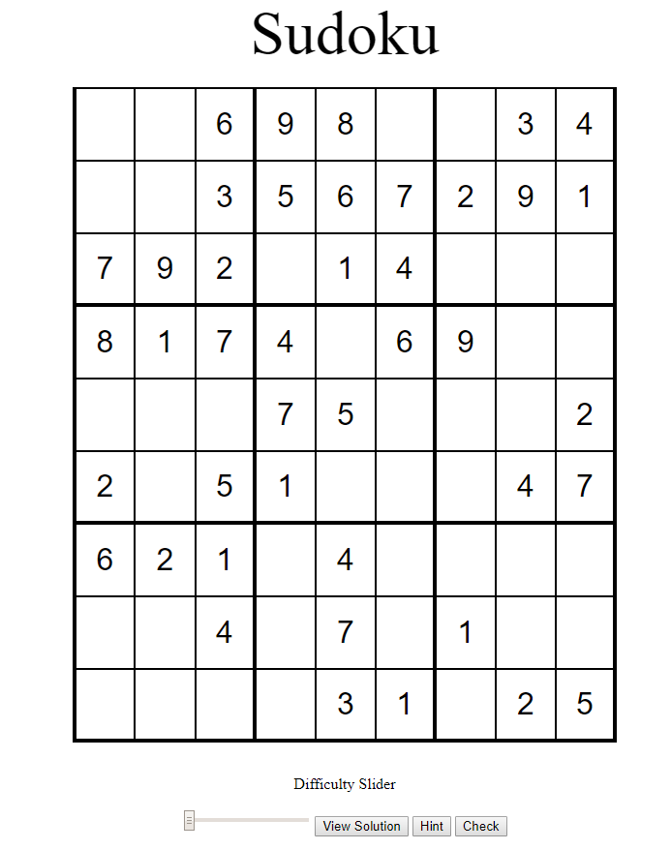

1. Create puzzle with medium difficulty

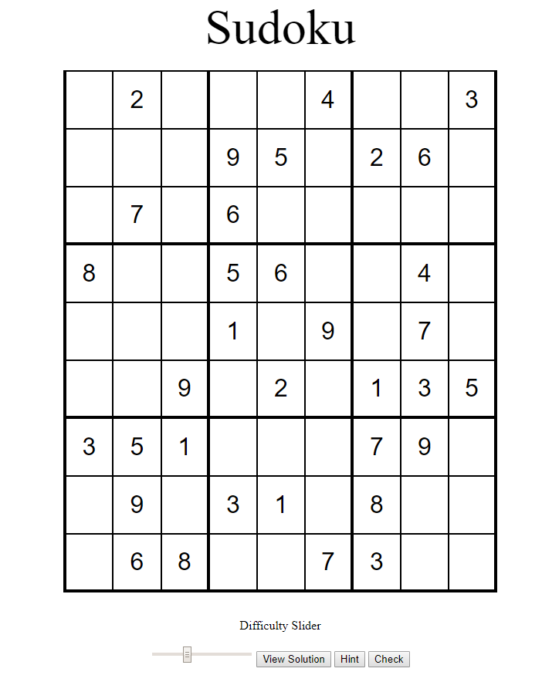

1. Create puzzle with hard difficulty

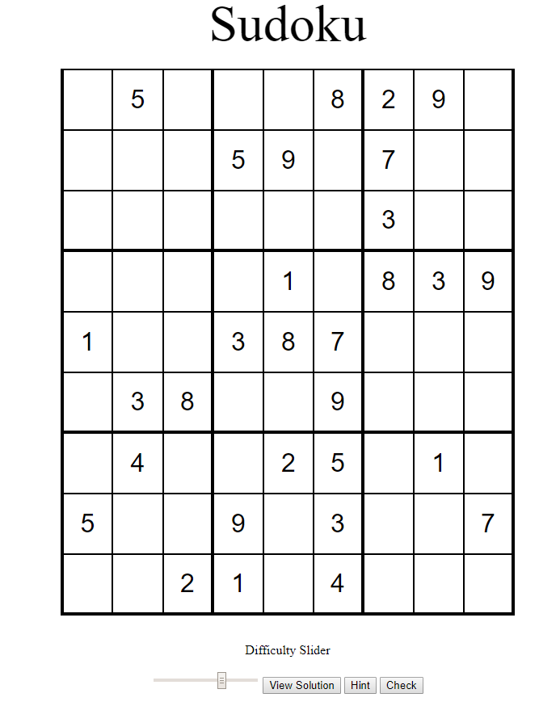

1. Create puzzle with Expert Difficulty

